Driving Directions to meet our bus in Canungra for your ballooning experience with Hot Air

Useful phone numbers:

Reservations (24 hours) – 1300 766 887 – Please quote your 6 figure booking reference number when you call.
If necessary, reservations can then put you in touch directly with the crew of the day.

Important – Please call us if you are running late and make sure that you have given us YOUR MOBILE PHONE NUMBER.

Please park your car and stand in front of the Tourist Information Centre in Kidston Street (just off the Main Street). Our driver will collect you in our bus around 5.20am (check the time you were given when you made your reservation).

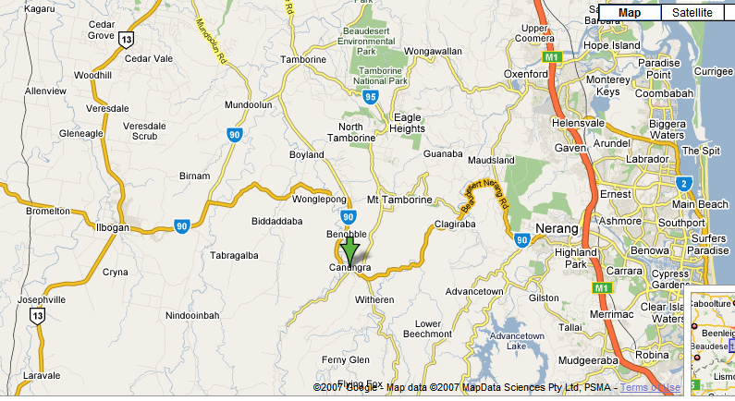

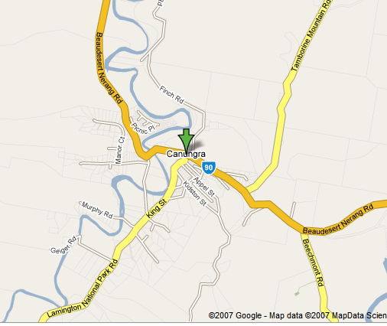

Approximate driving times from:

Tamborine Mountain is 20 minutes
O’Reilly’s Rainforest Resort is 30 minutes
Nerang is 20 minutes

